1. **cp file1.txt file2.txt**

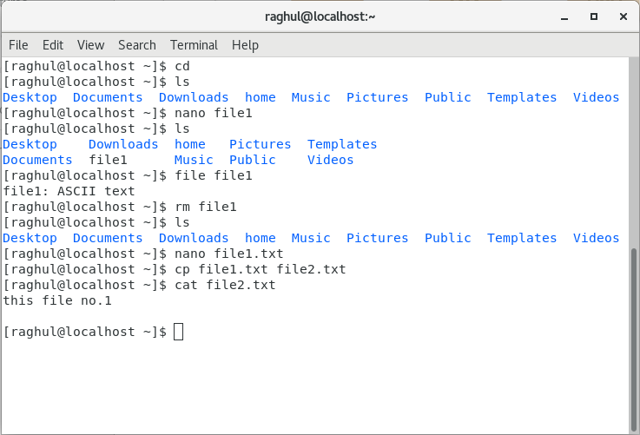

3. **mv file2.txt /home**

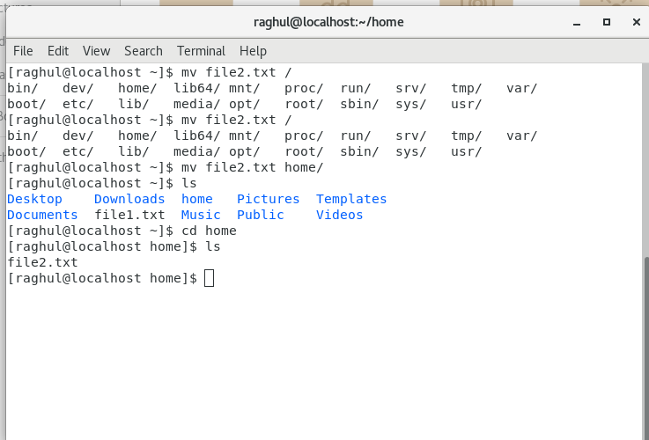

1. create a new **file3.txt and file4.txt** in **home directory**

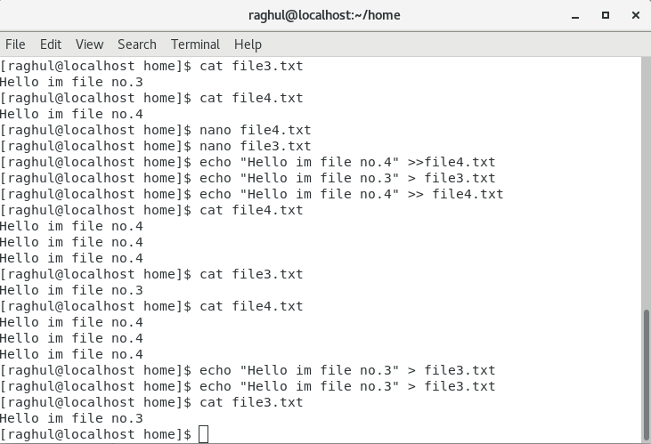

**“>”** means the content of the files are created or if the file is already in place, then the content of the file is overwritten.

“**>>**” means the new content is added on to of the old content and its not overwritten.